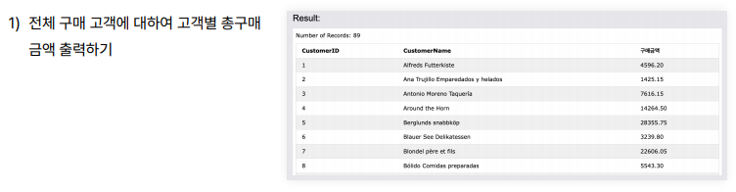

SELECT c.CustomerID,c.CustomerName, SUM(p.Price \* od.Quantity) AS "구매금액"

FROM Customers as c

JOIN Orders as o

ON c.CustomerID = o.CustomerID

JOIN OrderDetails as od

ON o.OrderID = od.OrderID

JOIN Products as p

ON od.ProductID = p.ProductID

GROUP BY CustomerID

ORDER BY CustomerID;

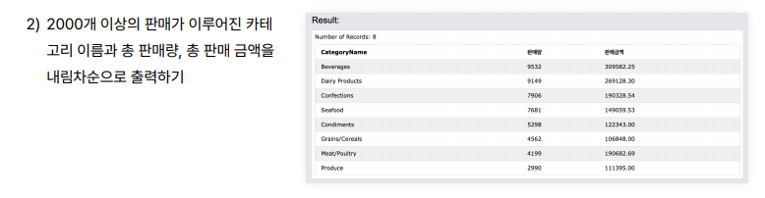

SELECT CategoryName, SUM(O.Quantity) AS "판매량", SUM(P.Price\*O.Quantity) AS "판매금액"

FROM Categories as C

JOIN Products as P

ON C.CategoryID = P.CategoryID

JOIN OrderDetails as O

ON P.ProductID = O.ProductID

GROUP BY C.CategoryName

HAVING SUM(O.Quantity) >= 2000

ORDER BY SUM(O.Quantity) DESC;



SELECT CategoryName, SUM(O.Quantity) AS "판매량", SUM(P.Price\*O.Quantity) AS "판매금액"

FROM Categories AS C

JOIN Products AS P

ON C.CategoryID = P.CategoryID

JOIN OrderDetails AS O

ON P.ProductID = O.ProductID

GROUP BY C.CategoryName

HAVING SUM(P.Price\*O.Quantity)>(SELECT SUM(P.Price\*O.Quantity)

FROM Categories AS C

JOIN Products AS P

ON C.CategoryID = P.CategoryID

JOIN OrderDetails AS O

ON P.ProductID = O.ProductID

WHERE C.CategoryName = 'Seafood'

GROUP BY C.CategoryName)

ORDER BY SUM(O.Quantity) DESC;